|  |  |  |  |
| --- | --- | --- | --- |
| PICTLOGO | **PUNE INSTITUTE OF COMPUTER TECHNOLOGY**  PUNE - 411043 | | |
| **Department of Electronics & Telecommunication** | | |
| ASSESMENT YEAR: 2016-2017 | | CLASS: BE - 8 |
| **SUBJECT: SOFT COMPUTING** | | |
| **Assg. No: 02** | **Roll No: Date:** | |

**STATEMENT:** To develop Hebbs’s nets for different logic gates

**PROGRAM:**

AND GATE:

clc;

close all;

clear all;

%inputs

x1 = [-1 -1 1 1];

x2 = [-1 1 -1 1];

%target outputs

z1 = [-1 -1 -1 1];

%initialization

y = [0 0 0 0];

b = 0;

w = [0 0];

wnew = [0 0];

%training

for i = 1:4

y(i) = w(1)*x1(i) + w(2)*x2(i) + b;

wnew(1) = w(1) + x1(i)*z1(i);

wnew(2) = w(2) + x2(i)*z1(i);

b = b + z1(i);

w = wnew;

end

%output display

disp('The Hebb net for AND Gate is trained');

disp('The weights and biases are');

disp ([w b]);

x = -10:10;

y = zeros(21);

for i = 1:21

y(i) = -(w(2)*x(i)+b)./w(1);

end

plot (x, y)

hold on

stem (x1, x2, 'LineStyle', 'none', 'Marker', '.')

hold off

**OUTPUT:**

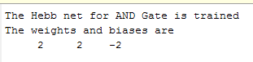

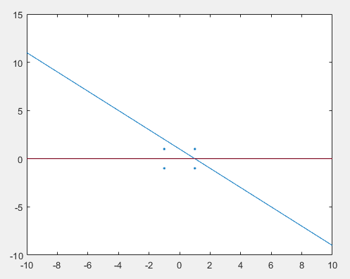

OR GATE:

clc;

close all;

clear all;

%inputs

x1 = [-1 -1 1 1];

x2 = [-1 1 -1 1];

%target outputs

z1 = [-1 1 1 1];

%initialization

y = [0 0 0 0];

b = 0;

w = [0 0];

wnew = [0 0];

%training

for i = 1:4

y(i) = w(1)*x1(i) + w(2)*x2(i) + b;

wnew(1) = w(1) + x1(i)*z1(i);

wnew(2) = w(2) + x2(i)*z1(i);

b = b + z1(i);

w = wnew;

end

%output display

disp('The Hebb net for OR Gate is trained');

disp('The weights and biases are');

disp ([w b]);

x = -10:10;

y = zeros(21);

for i = 1:21

y(i) = -(w(2)*x(i)+b)./w(1);

end

plot (x, y)

hold on

stem (x1, x2, 'LineStyle', 'none', 'Marker', '.')

hold off

**OUTPUT:**

